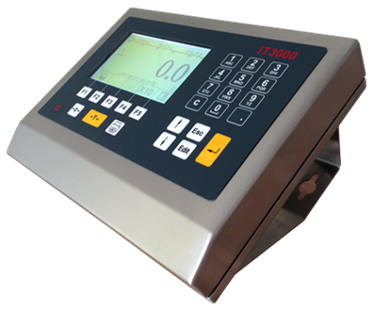

**T3000**

**Weighing Indicator**

**Operation Manual**

|  |
| --- |
|  |

|  |  |
| --- | --- |
|  | **WARNING** |
| **Please do setting, adjusting, testing and maintaining by professionals.** |

|  |  |
| --- | --- |
|  | **WARNING** |
| **Please keep indicator sound grounding.** |

|  |
| --- |
| **ATTENTION** |
| Please cut off power before making electrical connection on indicator  Wait for 30 seconds before indicator power on. |

|  |
| --- |
| **ATTENTION** |
| This indicator is electrostatic sensitive device, Please use Anti-static measures during operation and maintenance. |

|  |
| --- |
|  |

Catalogue

1. Overview 1

1.1 Technical Data 1

1.2 main function 2

1.3 outline dimension 2

1.4 model naming rules 2

2.0 installation 2

2.1 installation and adjusting 2

2.2 open box inspection 3

2.3 electrical connection 3

2.3.1 open indicator 3

2.3.2 analogue loadcell connection 3

2.3.3 digital loadcell connection 3

2.3.4 communication interface connection 4

2.3.5 power connection 4

2.4 indicator sealant 4

3.0 keypad introduction 5

4.0 function key to function icon introduction 5

5.0 weighing status icon introduction 6

6.0 basic operation 6

6.1 on/off 6

6.2 zero 7

6.3 tare 7

6.4 remove tare 8

6.6 weighing mode 9

6.7 print data 13

7.0 menue operation 13

7.1 basic data 13

7.1.1 unit 14

7.1.3 range and division value 16

7.1.3.1 capacity 16

7.1.3.2 division value 16

7.1.4 zero adjusting 17

7.1.5 cornering adjusting 17

7.1.6 linearity adjusting 18

7.1.7 calibration 19

7.1.8 expended display 21

7.2 application data 21

7.2.1 automatic zero tracking 21

7.2.2 zero function 21

7.2.3 tare set 22

7.2.4 Dynamic detection 22

7.2.5 digital filtering 22

7.3 indicator communication data 22

7.4 data managment 24

7.4.1 search by car number 24

7.4.2 search by time 25

7.4.3 weighing base clear 25

7.4.4 car number tare clear 25

7.5 diagnosis maintenance 25

7.5.2 serial port 1 testing 26

7.5.3 serial port 2 testing 26

7.5.4 display self-diagnostic 27

7.5.5 keypad testing 27

7.5.6 Default value loading 27

7.6 command setting 27

7.7 time setting 27

8.0 menue list 28

9.0 continuous output data format 29

9.1 single character command 30

10.0 default parameter 30

11.0 indicator maintenance 31

11.1 daily maintenance 31

11.2 pcb board 31

11.3 indicator hint information 32

11.4 program loading update 32

## 1.0 Overview

## 1.1 Technical Data

|  |  |
| --- | --- |
| **Accuracy** | C3,10000e degree |
| **Max division** | 100000d |
| **Display** | LCD,240X128 lattice STN blue |
| **Button** | Full digital keypad, navigation key, shortcut key, on/off key |
| **Digital filtering** | Multi-stage filtering adjusting |
| **Platform** | Analog load cell, HBM load cell, Keli E type load cell |
| **Load cell drive** | Max connecting 16 load cells |
| **Load cell interface** | RS485,Anti surge and lightning |
| **Communication port** | RS232C and RS485,printer,big screen, computer etc,  Available to add ether net, USB,SD port |
| **Power** | 100V~240V AC |
| **Protection class** | IP65 |
| **Working temperature** | -10℃ ~ 40 ℃ |
| **Application** | Normal weighing  store 1000 records of weighing  second time weighing  automatic identify gross weight and tare, 200 temporary records  preset tare weighing  Pre store 200 preset tare message |
| **Memory, Report** | by month search, by date search, by car number search |
| **Self-diagnostic function** | serial port self-diagnostic  display self-diagnostic  keypad self-diagnostic |

## 1.2 Main Function

* Connect HBM,C16i,Keli E,AWT T301 digital load cell
* Load cell communication isolation, anti-surge technology
* Support manual and automatic cornering adjusting.
* Chinese display, with navigation hint.
* 3 modes of truck scale weighing application
* Indicator data setting with code protection
* Have Chinese, English, Numbers 3 input ways
* Print and query, accumulate all kinds of reports
* Inside real-time clock
* RS232, RS485 interface.
* Can extend other industrial communication interface
* Self-diagnostic function

## 1.3 Dimension



## 1.4 Model Naming Rule

Model Description

* IT3000 Analog truck scale indicator
* IT3000D Digital truck scale indicator

## 2.0 Installation

## 2.1 Installation and Setting

This chapter introduces how to install and set IT3000 indicator. Please read carefully before installation and using

## 2.2 Open box inspection

When open box, check all parts be complete, if any missing or damaging, please contact our technical service department. Make sure all parts well then take out the indicator.

## 2.3 Electrical Connection

## 2.3.1 Open indicator

Screw off 10 screws to open the front housing of indicator.

Attention: Cut off the power before opening indicator, Please adopt electrostatic protection when electrical connection.

## 2.3.2 Analog Load cell connection

Analog load cell connection uses 7pin terminalJ3 on inside PCB.

Pin 1－ ＋EXC Positive

Pin 2－ ＋SEN Positive Feedback

Pin 3－ ＋SIG Positive signal

Pin 4－Shield shield ground

Pin 5－ －SIG Negative signal

Pin 6－ －SEN Negative feedback

Pin 7－ －EXC Negative incentive

If use 4 wiring load cell，Put pin1 and pin2 short circuit,pin6 and pin7 short circit.

## 2.3.3 Digital load cell connection

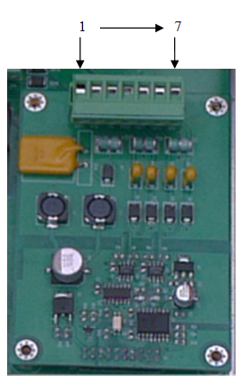

Digital load cell connection uses 7 pin terminals J3

Pin 1－＋12V power+

Pin 5 － A

Pin 6 － B

Pin 7 － GND power-

## 2.3.4 Interface connection

RS485 interface

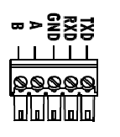

As right picture, wiring according to option board.

Pin 1 －B RS485 send-

Pin 2 －A RS485 send+

RS232 interface

As right picture, wiring according to option board.

Pin 3 － GND Grounding

Pin 4 － RXD receiving

Pin 5 － TXD sending

## 2.3.5 Power connection

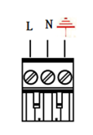

Power connection uses 3 pin terminals.

Pin 1 － L

Pin 2 － N

Pin3 － Grounding

Attention：Input power 100V~240VAC

## 2.4 Indicator Sealant

After indicator setting and calibration, use sealant to lock the housing.

## 3.0 Keypad introduction

|  |  |
| --- | --- |
|  | <On/off>, power on/off the indicator |
|  | <ok>。When menu，press ok to confirm。  Input numbers, press ok to confirm |
|  | <up>。When menu，press key to make cursor up. |
|  | <down>。When menu，press key to make cursor down |
|  | <left>。When input date，press key to make cursor left move. |
|  | <right>。When input date, press key to make cursor right move |
|  | <tare/tare remove>。When in Gross Weight，press key to make weight as tare value，indicator show“0”.When in net weight，press key to remove the tare value, back to the gross weight. |
|  | <Cancel>。When input, press key to back forward to cancel words |
|  | <Zero>。  When in gross weight, press key gross weight is“0”，cursor in 0. |
|  | <Exit>。When menu，will exit menu.  When input numbers, press key to exit input. |
|  | <Print>。Print current weight or value。Will save the value when print out. |
|  | <0>-<9> number。Input time, car No.；when in pinyin, letter, can input letter |
|  | <.>。use“.” when input number |
|  | <F1>-<F5> function keys。Have different functions when in different display。Showing which operation to make according to display cursor. |

## 4.0 function keys corresponding function icon

|  |  |
| --- | --- |
|  | Weighing mode option。Can switch during first time weighing, second time weighing, preset tare, normal weighing modes。 |
|  | Weighing value collect，per car number, date collect, tare collect, once temp data collect. |
|  | Input car number |
|  | Input cargo number |
|  | Enter data setting |

## 5.0 Weighing state icon

|  |  |
| --- | --- |
|  | Net weight icon。Display net weight，icon light, shows  display shows gross weight, icon not light shows。 |
|  | dynamic icon。When scale is dynamic, icon light, shows 。  when scale is static，icon not light, shows |
|  | “0”icon  when scale during gross weight 0±1/4d，the icon shows  when not 0，icon not light, shows |

## 6.0 Basic operation

## 6.1 On/off indicator

Turn on the indicator，press on/off key, display model and software version，and will self-diagnostic，then turn to main interface。After power on，when load on scale platform, there show:。

indicator main interface：

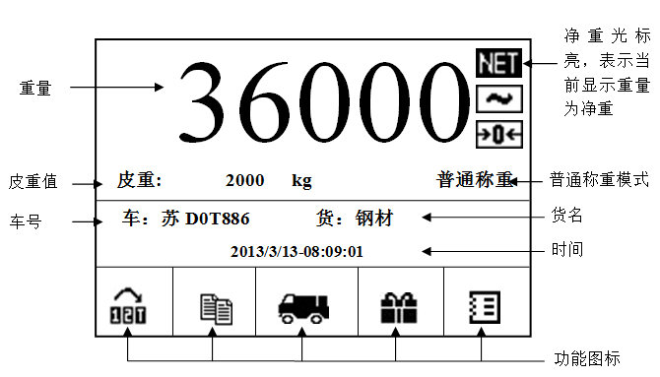

Press “on/off” key 2 seconds to turn of the indicator power.

## 6.2 Zero

* Turn on Zero:

IF turn on zero set, and goods capacity on range of zero, it will automatic zero when turn on indicator, “zero” icon lights on.

Automatically zero and zero range can be set. Main menu“ -“scale application data”

-“zero function”-“setting turn on zero”

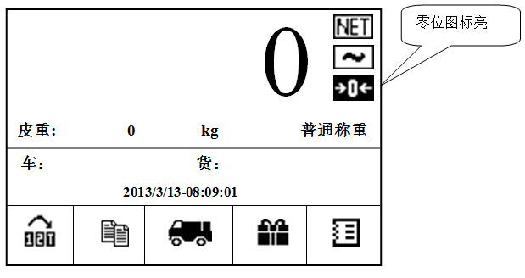

* Manual Zero

press <zero>，make indicator display zero at permitted range.



Attention：Below situations cannot set zero 1）display dynamic；2）keypad zero forbidden；3）the weights more than range of set zero. Zero setting range can be set in menu:“main menu”-“scale application data”-“zero function”-“keypad zero set”

## 6.3 Tare key



In gross weight, press <tare>key，indicator read“0”，and save current weight as tare.

Attention：in dynamic or net weight, cannot proceed tare or zero operation.

E.g. in gross weight, weights 2000kg press<tare>,

Indicator read：

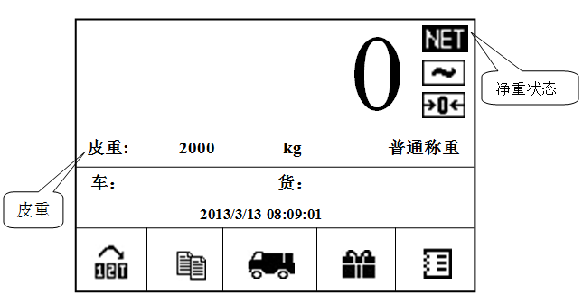

## 6.4Remove tare

In net weight, press <Tare> will remove tare，makes indicator back to gross weight

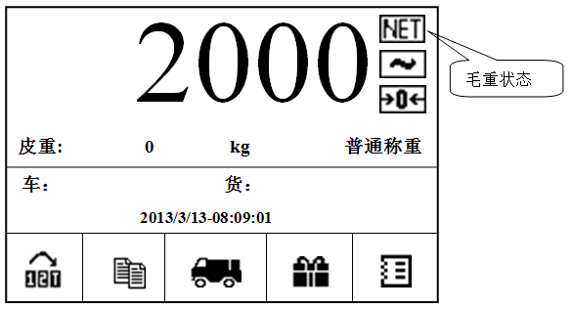

6.5 Input method

* Input shift

Get into input surface，e.g. car number input, press“swift” to make“number、letter”swift. See details below:

* Number input：Swift to number input, press number.
* letter input： swift to letter input, press number，each number has letter indicate，e.g. press“Ch”,press button 3times，indicator will shows letter“C”；press 5times，it will show“h”。

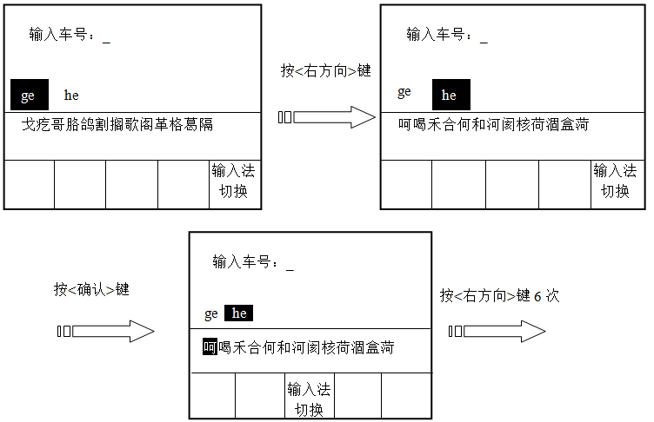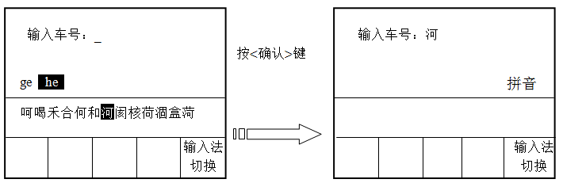

others：when letter input，press“0” can get“( ) / | \ % * -” etc

## 6.6 Weighing mode

For convenient weight, it has 4 weighing modes: first weigh、second weigh, tare preset,

normal weigh.

* First weigh

In weighing surface press<F1>into“select weighing mode”，press<F1> select first weigh”。

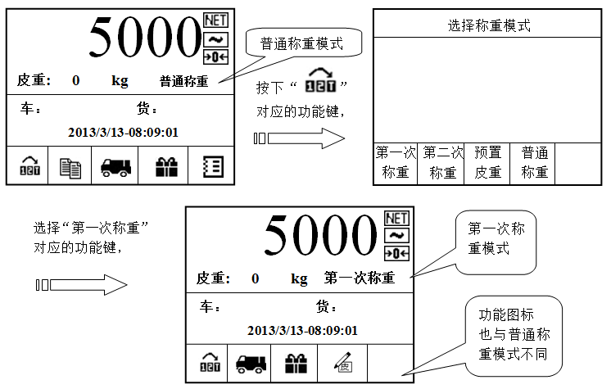

Car number input



press “ ”，input car number, support number, letter or Chinese character（10characters most, Chinese character2）,Press <F5> can swift between “number, letter, pinyin”

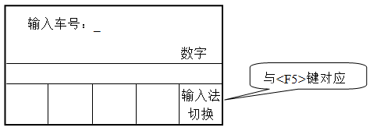

E.g.input car no.“苏D 0T886” press<confirm>。Car no. will show below:

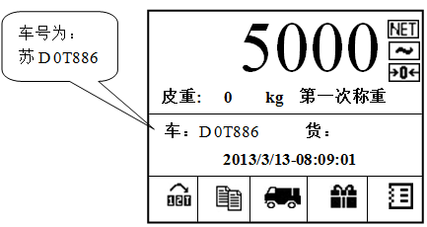

Cargo number

press“ ”can input cargo number, support number, letter（10characters most, chinese character2）press“swift” <F5> can swift between“number, letter, pinyin”

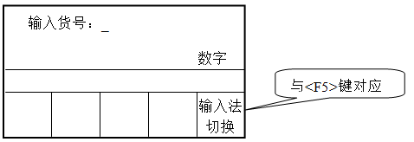

E.g.：input“钢铁”press<confirm>。 Car number will show below：

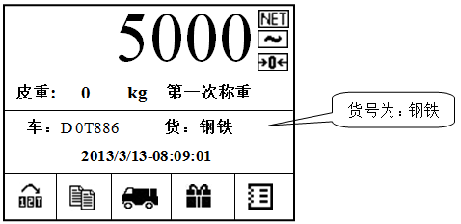

Press“ ”，indicator shows“first time saved”

Attention：If this car no. weighing data saved，save again, indicator will shows “appeal repeat, press<confirm> to turn back.

* Second weigh

In weighing surface press<F1> into“select mode”,press<F2> select“second weigh”

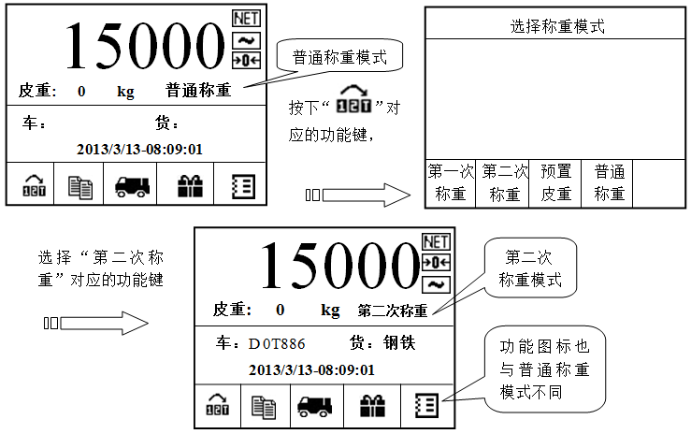

Press print“ ”，indicator will print the weight datas.



Series Date Time Car number Cargo no. Gross Weight Tare Net Weight

12013/03/13 08:09:01 苏D0T886 钢铁 15000 kg 5000 kg 10000 kg

* Preset tare weighing mode

In this mode，when put car no., if its tare data has saved before, it will use this data，to proceed tare remove, if this car tare data has not saved, then input tare data.

Car number tare data invoking

E.g.: press“ ”，input car no.“苏D0T886”. press <confirm>key.



If car no.“苏D0T886”tare data saved before, then it will invoking its tare data（e.g.：5000kg）,proceed tare remove. Indicator will swift to static status display, as below:

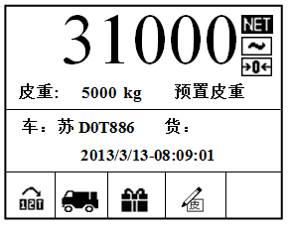

Input tare data and save



If input another car no “苏D1T552”,this car no. has no tare saved, then press “ ”.

And input tare data，press<confirm>,indicator proceed tare remove,and save car no.and tare date, next time will invoking.

If one car no.tare data has saved。Input tare data,indicator will show “car no. exsists,change tare data or not？”If press <confirm>,then indicator will update the tare data.Press<back> to not save new tare data.

* Normal weighing mode

When no need first weigh, second weigh and preset tare weighing mode, users can use normal weighing mode. Under this mode, input car no., cargo no.，press “tare” to remove tare, press print to print out and save data.

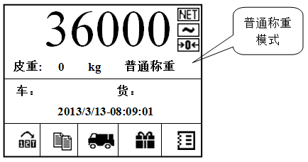

Data Summary

Press“ ”key to operate data summary.

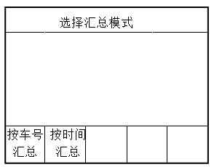

“Summarizing by car no.”and “summarizing by time” operating are same. “summarizing by time” for example, when select “summarizing by time”，indicator display below:

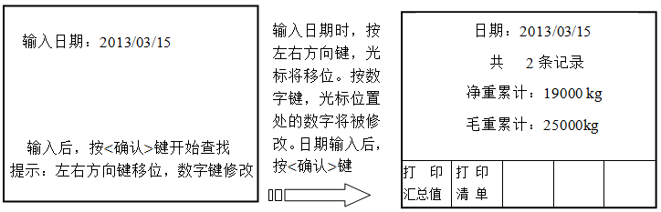

Search end, indicator will show record on current date, net weight accumulated value and gross weight accumulated value. If choose “print summary value”, print summary value format as below:

Summary report

----------------------------------------------------------------------------

Date：2013/03/15 times： 2

Gross Weight cumulated：25000kg Net weight cumulated：19000 kg

If in front surface, choose“print detail list”，every data will be print out, then print accumulated data. Print summary report format as below:

Summary report

Serial Date Time Car No. Cargo No. Gross weight Tare Net weight

----------------------------------------------------------------------------

1 2013/03/15 08:22:03苏D0T886 steel 9000 kg 3000 kg 6000 kg

2 2013/03/1508:31:17 苏D0T886 steel 16000 kg3000 kg 13000 kg

----------------------------------------------------------------------------

Gross weight cumulated：25000kg Net weight cumulated：19000 kg

If want to check every weighing details, enter to“data set menu”→“Data manager”→“search by car no.”（or“search by time”）. Detailed operating see later introduction.

Weighing mode swift



Press“ ”，can swift between first weight, second weigh, preset tare

## 6.7 Print data

Under the weighing，press <Print>can print out weigh list，value will be saved same time to current data base。There are 3 formats of list，can set in menu: “index set menu”→“indicator communication index”→“serial port1（RS232）”→“weigh list format”。Set serial port2 in same way

Attention: only serial port output is set “print mode”can print data

## 7.0 Menu operation

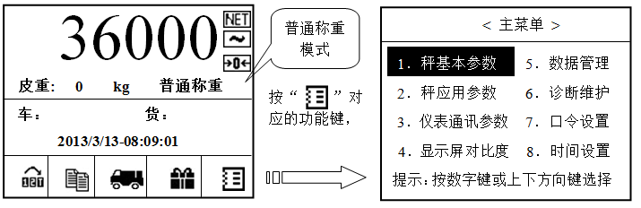

Press up、down key or number to select item, then press confirm key to enter.

|  |  |
| --- | --- |
| **Hint** | **Press number key can move icon to item in menu. E.g.“3．Indicator communication index”，press “3”directly is ok.**  **After index is set, back from main menu to weighing surface, indicator show press“confirm” to save the revised data, press back will not save the data.** |

## 7.1 Basic parameters

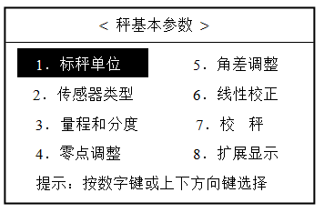

## 7.1.1 Calibration unit

Default unit “kg”

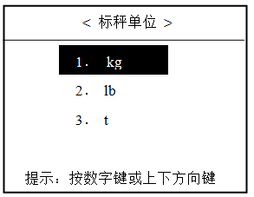

**7.1.2 Load cell type**

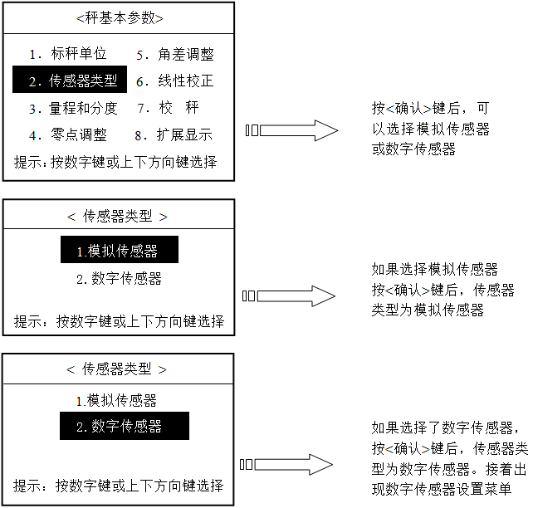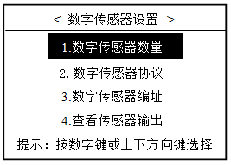

* Digital load cell quantity

Enter the menu shows current quantity, press <confirm> to input revised quantity, input quantity from 1~16pcs

<Digital load cell Qty>

Hint: press<confirm>to done,<back>to return

Digital load cell Qty ：1

* Digital load cell protocol

Support FLINTEC RC3D digital load cell.

< Digital load cell protocol>

>

1. FLINTEC

2. HBM

Hint: press number key or up down key to select

* Digital load cell addressing

<Set address according to serial no.>

Digita1 load cell address:_

Hint: Max input 9 numbers

Input serial no.：_

<Set address according to serial no. >

1. 123456789
2. 1122335678
3. 1223356689
4. 1223356690

Hint: press number key or up down key to select

Above surface, selected means： address 1，serial no.123456789. Others means address 2~4loadcells, pick one digital load cell, press<confirm> can set its serial no.（Attention: digital load cell quantity depends on the quantity set before）.

Digital load cell address of truck scale, see below, the numbers are address, convenient to cornering adjusting.

11

9

7

5

3

1

4

2

12

10

8

6

Digital load cells of truck scale diagram

* Load cell output

Can check all digital load cells inside graduation

<Load cell output >

1. 42241
2. 61354
3. 64557
4. 54457
5. Hint

提示：按<退出>键返回

## 7.1.3 Range and division value

## 7.1.3.1 Full range

## Set the full range of scale as the max capacity.

## 7.1.3.2 Division value

Set up division value of scale, min. changing weight value, use“d”

Allowed input division value: 0.01，0.02，0.05，0.1，0.2，0.5，1，2，5，10，20，50，100，200，500，1000，2000，5000

state**：**show number of divisions＝full range÷division value。

Max show number of division 60,000

Min show number of division 100

Show number of division must be [integral](javascript:void(0);) [multiple](javascript:void(0);) of 100

## 7.1.4 Zero adjustment

Enter to zero adjustment, indicator show as below:

Clear the scale

Press<confirm>to calibrate

Zero adjustment

Clear the scale

Press<confirm>calibrate

calibration定

Press<back> to return

Record empty scale weight

In the end, indicator shows:“zero adjustment finished”.

## 7.1.5 Cornering adjustment

This data used for cornering adjustment, can select manual and automatic cornering adjustment, this operation must be done before calibration.

* Manual cornering adjustment

Select manual cornering adjustment, press<confirm> to enter to manual cornering adjustment surface.

<Cornering adjustment>

1.manual cornering adjustment

2. Auto cornering adjustment

Hint: press number key or up down key to select

< Manual cornering data> adjust >

Digital load cell address：1

Hint: Max input 8 numbers

Input cornering data: _

Selected show: address1 cornering data is 1.001865,press <confirm> to revise

<Manual cornering data adjust >

1. 1.001865

3. 1.002300

Hint: press number key or up down key to select

4. 1.001600

2. 1.001350

Revise other address cornering data in the same way.

* Automatic cornering adjustment

Select automatic cornering adjustment, press<confirm> to enter automatic cornering adjustment surface

<Cornering adjustment>

1. Manual cornering adjust

2.Automatic cornering adjust

Hint: press number key or up down key to select

Empty scale test

First clear scale

Press<confirm> to calibrate

Press<back> to return

Keep scale empty and stable, press<confirm>and then

Record empty scale

After empty scale record, the indicator show below:

At least load 10% of full capacity to corner1, press<confirm>, then

Load in No.1 load cell

Load at least 10% of full capacity

Press confirm to start

Press<back> to return

Calculating cornering data…..

After address 1 cornering adjustment, indicator will show to load address 2 load cell, follow the above way to do cornering adjustment one by one.

## 7.1.6 [Linearity](javascript:void(0);) [correction](javascript:void(0);)

Hint: press number key or up down key to select

1．Forbidden

2．Allowed

< [Linearity](javascript:void(0);) [correction](javascript:void(0);) select>

It can set 3 poits [linearity](javascript:void(0);) to correct. If allowed, there will be 2 loading poits.

## 7.1.7 Calibration scale

* Calibration (If: [linearity](javascript:void(0);) [correction](javascript:void(0);) select forbidden)

Operation e.g.：use 20t weights to calibrate 20t scale（set up capacity 20000kg and division value 10kg）

Press<confirm>key

4．Zero adjustment

8．Expending display

7．Calibration

Hint: press number key or up down key to select

1．Unit

2．Load cell type

3．Capacity and division

5．Corner adjustment

6. L[inearity](javascript:void(0);) correction

<Basic index >

First step: zero calibrate

Clear the scale

Press<confirm> to calibrate

Press<back> to return

Record empty scale weight

…..

Clear the scale, press<confirm>,then

Record load weight…..

Second step: load weight

Recommend load 20%-100% full capacity

Press<confirm>record weight

Press<back> to out calibrate

Input load weight：kg

Load weights, input

20000, press<confirm>

**Attention：**1）load weight should not less than 20% of Max capacity, recommend to use 60-100%,if when calibrating, the weight is unstable, might cannot continue to calibrate, please follow the indicator hint to operate.

* Linearity calibration(if allowed)

Normal situation, no need to use linearity calibration, use“standard calibration”.When meet bad weighing linearity, can use this function to correct.

Press<confirm>key

4．Zero adjustment

8．Expending display

7．Calibration

Hint: press number key or up down key to select

1．Unit

2．Load cell type

3．Capacity and division

5．Corner adjustment

6．[Linearity](javascript:void(0);) correction

<Basic index >

First step: zero calibrate

Clear the scale

Press<confirm> to calibrate

Press<back> to return

Record empty scale weight

…..

Clear the scale, press<confirm>,then

Load weights，

input20000, press<confirm>

Second step: load high weight

Input load value：kg

Record load weight…..

Recommend load 20%-100% of full capacity

Press<confirm> to calibrate

Press<back>to return

Second step: load low weight

Press<confirm> record saved

Press<back> to return

Input load weight：kg

Load weights，

Input 10000，

Press<confirm>

Record load weight…

## 7.1.8 Expend display

Select if allow expend display, the data is 10times weight. If normal is 40.96，after expend, it is 40.958. This function is for internal adjust, default is no expend display.

## 7.2scale application index

Hint: press number or up down to select

1．Auto zero tracking

2．Zero function

3．Tare set

4．Dynamic test

5．Digital filtering

<Scale application index>

## 7.2.1 Auto zero tracking

Turn on/off auto zero tracking, can select：“forbidden zero tracking”、“0.5d”、“1d”、“3d”（d：division value）

## 7.2.2 Zero function

* Set keypad zero range

Hint: press number or up down to select

1．Auto zero tracking

2．Zero function

3．Tare set

4．Dynamic test

5．Digital filtering

<Scale application index>

Press <confirm>

Press<confirm>

Hint：press number or up down to select

1．Set keypad zero

2．Set turn on zero

<Zero function>

Hint：press number or up down to select

1．Forbidden zero

2． 2% of full capacity

<Set keypad zero >

3.10% of full capacity

4.20% of full capacity

* Set turn on zero

Hint: press number or up down to select

1．Auto zero tracking

2．Zero function

3．Tare set

4．Dynamic test

5．Digital filtering

<Scale application index>

Press <confirm>

Press<confirm>

Hint：press number or up down to select

2．Set turn on zero

1．Set keypad zero

<Zero function>

Hint：press number or up down to select

1．Forbidden zero

2． 2% of full capacity

<set keypad zero >

3.10% of full capacity

4.20% of full capacity

## 7.2.3 Tare set

Set if allowed tare remove，select：“forbidden”、“allow tare remove”

## 7.2.4 Dynamic test

Set if can dynamic test and the range, select：“forbidden dynamic test”、“0.5d”、“1d”、“3d”

## 7.2.5 Digital filtering

Set digital filtering range, select“mild filtering”、“middle filtering”、“heavy filtering”. The heavier filtering, the display is more stable.

## 7.3 Indicator communication parameter

Set serial port 1 and serial port 2.set is same, e.g. set serial port 1:

Press<confirm>

Hint: press number or up down to select

1．Baud rate

2．Data bits

3．Check bits

4．Output way

5．Weigh list format

<serial port 1(RS232) >

6．Print title set

Hint: press number or up down to select

1．Serial port 1（RS232）

2. serial port 2（RS485）

<Communication index>

* Baud rate

Set baud rate for serial port, select：“1200 b/s”、“2400 b/s”、“4800 b/s”、“9600 b/s”、“19200 b/s”。

* Digital bits

Set digital bits for serial port, select：“7 bits”、“8 bits”

* Check bits

Set check bits for serial port, select“no check”、“odd check”、“even check”。

* Output way

Set output way for serial port, select：“forbidden output”、“continuous output”、“print mode”。

If need connect printer, set output way to“print mode”.

* Weigh list format

Set print format, select A、B、C formats.

**Format** A**：**

Basco Basco Basco

Weigh list no.1 Weigh list no.2 Weigh list no.3

|  |  |  |  |  |  |  |  |
| --- | --- | --- | --- | --- | --- | --- | --- |
| serial | 10 |  | serial | 10 |  | Serial | 10 |
| Time | 15:00:00 |  | Time | 15:00:00 |  | Time | 15:00:00 |
| Date | 2013/03/13 |  | Date | 2013/03/13 |  | Date | 2013/03/13 |
| Car no | 12345678 |  | Car no | 12345678 |  | Car no | 12345678 |
| Cargo | steel |  | Cargo | Steel |  | Cargo | steel |
| G.W. | 1000kg |  | G.W. | 1000kg |  | G.W. | 1000kg |
| Tare | 500kg |  | Tare | 500kg |  | Tare | 500kg |
| N.W. | 500kg |  | N.W. | 500kg |  | N.W. | 500kg |

**Format** B**：**

Serial Date Time Car no. Cargo no.G.W. Tare N.W.

---------------------------------------------------------------------------

1 2013/08/09 08:22:03 12345678 steel 3000kg 200kg 2800kg

**Format** C**：**

serial Date Time Carno. Cargo no. G.W. Tare N.W.

---------------------------------------------------------------------------

1 2013/10/09 08:10:0312345678 steel 8000kg 1200 kg 6800kg

2 2013/10/09 09:20:12811111 steel 2000 kg 500kg 1500 kg

3 2013/10/09 10:00:3792222222 steel 5000kg 2000 kg 3000 kg

**Attention: this format title only can be print when indicator first power on.**

## 7.4 Data management

## 7.4.1 Search by car no.

Search pointed car no. weigh data

Press<confirm>

Hint: press number or up down to select

2．Search by time

3．Weigh data cancel

4．Car no tare cancel

<Data management>

1．Search by car no.

<F5> same to

Input swift

Number

Input car no.：_

Car no. support number、letter （most 10 C, Chinese 2C）.press“input swift”<F5> can swift between“number、letter、pinyin”.E.g.: input“苏D 0T886”press<confirm>,If find the weigh data for this car, will show below：

Press<confirm>keep search, press<back>to return

cargo：Steel

Tare：1500 kg

N.W.：5000 kg

Time ：2013/03/15-13:03:23

Car no.：苏D 0T886

Record 1

Press <confirm>

Press<confirm>keep search, press<back>to return

Cargo no.：Steel

Tare ：1500 kg

N.W.：6000 kg

Time ：2013/03/15-13:12:05

Car no.：苏D 0T886

Record 2

Keep press<confirm>, if the search over, it shows:

Hint: press<confirm> to end search

N.W. total ：11000 kg

Search over

Total: 2 records

Indicator shows the result of N.W.total values. Press<confirm> to end and return.

## 7.4.2 Search by date

Search the appointed date weigh data。

Hint: press number or up down to select

1．Search by car no

2．Search by date

3. Weigh base cancel

4Car no. tare cancel

<>

Press <confirm>

Hint: left right key to remove, press number to revise

Press<confirm> to search

Input date：2013/03/15

Input date, press left right keys, icon moves. If press number, the number will revise. After press date, press<confirm>, it will search data according to date. When found, the information will shows as same search by car no..

## 7.4.3 Weigh base cancel

Select if to cancel weigh base summary. If“yes”，all weigh data will be cancel.

Once canceled, cannot be recover. Please be careful to operate.

## 7.4.4 Car no. and tare cancel

Select if to cancel car no. and tare. If“yes”,all the data of car no. and tare will be canceled.

## 7.5 Diagnose maintenance

**7.5.1 Checking the correction data**

Hint: press number and up down to select.

1．Check correction data

2．Serial port 1 test

3 serial port 2 test

4．Self-inspection

5．Keypad test

<Diagnose maintenance>

6．Load default item

Press<confirm>

If select“forbidden linearity correction ”in “scale application index”, shows below:

Hint: Press number and up down to select

1．Zero reading

2．Load weigh value

3．Weight value record

<Check correction data >

Press <confirm>

Hint:Press<confirm>to revise, press<back> to return

Zero reading： 679197

<Zero reading>

Indicator shows zero reading. If need to change zero reading, press<confirm>to input new value “load weight value”and“weight sample record”search and revise are same as zero reading.

If select“allow linearity correction”in“scale application index”，it shows below:

Hint: Press number and up down to select.

1．Zero reading

2．Low load weight value

3．Low sample value

<Check correction data >

4．High load weight value

5．High sample value

Check and revise data operation are same as above.

## 7.5.2 Serial port 1 test

Test serial communication port 1. Press any key to exit.

Hint: press any key to exit

Send—————receive

0 0

Cut power before test，short receive, send port

<Serial port 1 test>

Cut power before test, short connect（RXD）、(TXD).Serial port send“0”~“9”，continuously, receiving will show on surface. Check if sending and receiving CH are same.

## 7.5.3 Serial port 2 test

0

Send

<Serial port 2 test>

1

Send

Exit

Press “1send” <F2>key, serial port 2 will continuous send “0xFF”CH.

Press“0send”<F3>key, serial port 2 will continuous send “0x00”CH.

## 7.5.4 Display self-inspection

Display inspection, enter this function, display will shows, after full display shows, it will light off. If there has one place cant light up or off, then it might be detective display. Press <back> to exit inspection.

## 7.5.5 Keypad test

Key test, enter this function, except <exit> and <on/off>, keys will show related information, if cant show there might be defective. Press <back> to exit test.

## 7.5.6 Load default value

Select if load default value. Only use when indicator works wrong.

## 7.6 Command set

In normal work, to protect enter indicator and revise by mistake, can set command. Input command before enter indicator. Command can be number or letter. As below：

Press<confirm>

Hint: Press number and up down to select.

1．Basic parameter

2Scale application index

3.Communication index

5. Data manage

6Diagnose maintain

<Main menu>

7．Command set

4．Display contrast

8．Time set

<Command set>

Letter

Input swift

Input command：_

Input letter, press<confirm>, command saved. Please remember code, or else cannot enter indicator. If to cancel code, input no code when enter, confirm and return.

## 7.7 Time set

Enter time set, it shows:

2013/3/01- 11:00:25

<Date/Time set>

Hint: left right key to remove, press number to revise

When input date/time, press left right to move icon. If press number, will revise. Press<confirm>,update date/time.

## 8.0 Menu list

Main menu

6 Load default value

5 Keypad test

4 Display self-inspection

Diagnose maintenance

Display contrast

5 Once data

cancel

4 Car no./ Tare

cancel

3 Weigh base cancel

2 Search by time

1 Search by Car no.

Data management

Communication parameter

参数

5 Digital filtering

3 Tare set

4 Dynamic test

2 Zero function

1 Auto zero tracking

Scale application parameter

8 Expend display

Basic parameter

7 Calibration

6 Linearity correction

5 Cornering adjustment

4 Zero adjustment

3 Capacity and division

2 Load cell type

1 Unit

Time set

Command set

1 check calibration value

1. Serial port 1

(RS232)

2. Serial port 2

(RS485)

2 Serial port 1 test

3 Serial port 2 test

## 9.0 Continuous data output format

Serial port can output data continuously. Normally connect screen and display.

Continuous output format is 18(Bytes)：

|  |  |  |  |  |  |  |  |  |  |  |  |  |  |  |  |  |  |
| --- | --- | --- | --- | --- | --- | --- | --- | --- | --- | --- | --- | --- | --- | --- | --- | --- | --- |
| Continuous output format | | | | | | | | | | | | | | | | | |
| STX | A | B | C | X | X | X | X | X | X | Y | Y | Y | Y | Y | Y | CR | CKS |
| 1 | 2 | | | 3 | | | | | | 4 | | | | | | 5 | 6 |

Among：

<STX> ASCII start with (02H)。

State A,B,C。

Show weight might be G.W or N.W. 6 bits without symbol and the number of decimal point.

Tare 6 bits without symbol and the number of decimal point.

<CR> ASCII (ODH)。

<CKS> check and

|  |  |  |  |  |
| --- | --- | --- | --- | --- |
| State **A** | | | | |
| **Bits0,1,2** | | | | |
| 0 | 1 | | 2 | Decimal point |
| 0  1  0  1  0  1  0  1 | 0  0  1  1  0  0  1  1 | | 0  0  0  0  1  1  1  1 | XXXX00  XXXXX0  XXXXXX  XXXXX.X  XXXX.XX  XXX.XXX  XX.XXXX  X.XXXXX |
| **Bits3,4** | | | |  |
| 3 | | 4 | | Division value |
| 1  0  1 | | 0  1  1 | | X1  X2  X5 |
| **Bit5** | | | | Constant be 1 |
| **Bit6** | | | | Constant be 0 |

|  |  |
| --- | --- |
| State **B** | |
| **Bits** | Function |
| **Bit0** | G.W.=0,N.W.=1 |
| **Bit1** | symbol:+=0,-=1 |
| **Bit2** | overload(<0)=1 |
| **Bit3** | dynamic=1 |
| **Bit4** | Unit: kg=1 |
| **Bit5** | Constant be 1 |
| **Bit6** | Power on 1 |
| State **C** | |
| **Bit0** | Unit: lb=1 |
| **Bit1** | Unit: t=1 |
| **Bit2** | Constant be 0 |
| **Bit3** | Print command =1 |
| **Bit4** | Expend display(X10)=1 |
| **Bit5** | Constant be 1 |
| **Bit6** | Constant be 0 |

## 9.1 CPTZ single character command

IT3000C serial port set as continuous output and print, at the same time indicator can receive outside device input CPTZ single character command, can easy realize communication between indicator and outside device.

Command as single big character, sent by computer, indicator will operate the command when receive. But no reply value.

Detailed command and meanings:

P – print, indicator will according to set format, print out weight data by serial port.

T – tare, indicator operate tare command. Put current weight as tare to remove.

C – clear tare, indicator operate clear tare.

Z –zero, indicator operate Zero.

## 10.0 Default parameter

|  |  |  |  |  |  |  |  |
| --- | --- | --- | --- | --- | --- | --- | --- |
| **Parameter** | **Default value** | | | **Parameter** | | **Default value** | |
| 1.Scale basic parameter | | | | Serial port 2(RS485） | |  | |
| Unit | | kg | | Baud rate | | 19200 | |
| Load cell type | | Analog load cell | | Digital bits | | 8bits | |
| Capacity and division value | | 10000kg,1kg | | Check bits | | No check bits | |
| Zero adjustment | | NA | | Output way | | Continuous output | |
| Cornering adjustment | | NA | | Weight list format | | Format A | |
| Linearity calibration | | Forbidden | | Print title set | |  | |
| Calibration | | NA | | 4.Contrast set | | | |
| Expend display | | Forbidden | | Contrast | | 45 | |
| 2. Scale application parameter | | | | 5. Data management | | | |
| Autozero tracking | | | ±0.5d | Search by car no. | | |  |
| Zero function | | |  | Search by time | | |  |
| Keypad zero set | | | Full capacity ±2% | Weigh base search | | |  |
| Turn on zero set | | | Full capacity±10% | Car no. tare search | | |  |
| Tare set | | | Allow tare function | One time data cancel | | |  |
| Dynamic test | | | ±0.5d | 6.Diagnose maintenance | | | |
| Digital filtering | | | Heavy filtering | Check calibration value | | |  |
| 3.Indicator communication parameter | | | | Serial port 1 test | | |  |
| Serial port1(RS232) | |  | | Serial port 2 test | | |  |
| Baud rate | | 19200 | | Display self-inspection | | |  |
| Digital bits | | 8 bits | | Keypad test | | |  |
| check bits | | No check bits | | Load default value | | |  |
| Output way | | Print mode | | 7.command set | | | |
| Weigh list format | | Format A | | 8.Time set | | | |
| Print title set | |  | |  |  | | |

## 11.0 Indicator maintenance

## 11.1 Daily maintenance

Use cotton cloth with neutral detergent to clean indicator outside. Keep clean. Do not use industrial solvent to clean keypad and display. Neither spray onto the indicator.

Suggesting let professional person to regularly check the indicator and make record.

## 11.2PCB board

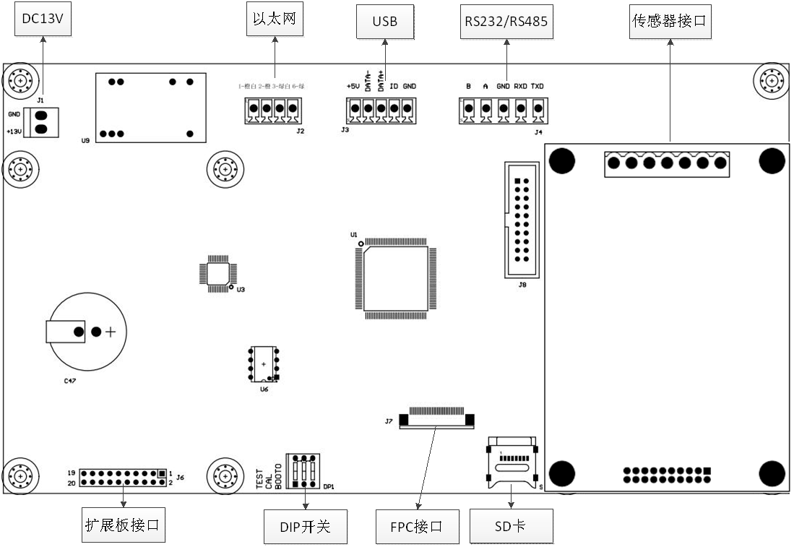

DIP on/off instruction:

CAL：down（allow calibration），up（forbidden calibration）；

TEST：Default to down state

BOOT0：Default to down state

## 11.3 Indicator hint information

|  |  |  |
| --- | --- | --- |
| **Hint information** | **Might situation** | **Solution** |
| Overload | Weight over full range 9d | Reduce the weight |
| Under load | Weight below 0 9d | Press zero |
| Input weight too big | When calibration, input more than full range | Retype load weight |
| Input weight too small | When calibration, input less than 2% of full range | Retype load weight |
| Command failed | Enter to set menu, input wrong code | Retype code |
| Reduce one time weigh record | Print second time weigh directly | Must do second weigh after first weigh |
| Duplicating | First weigh, car no, shows twice, will hint | Check if car no. is right, do first weigh again |
| Platform weight >0 | First or second print should be empty scale | Load weight |
| Cornering calculation wrong | Not enough weight on platform | Load weight to do cornering adjustment |
| Check empty scale failed | Scale is dynamic when calibration | Check the scale |
| Can not revise address | When serial no. revise load cell address, will appear. | Check the cable between indicator and load cell |
| Forbidden calibration | When CAL up, cannot set scale parameter. | CAL down |
| FLASH wrong | FLASH check default | Contact technical person |
| EEPROM wrong | EEPROM check default | Contact technical person |
| Data base wrote wrong | FLASH save show problem | Contact technical person |

## 11.4 Program download update

Indicator can update program, Use serial port on PC and special software to download updated program.

If update needed, please contact technical person of our company.

